Agenda
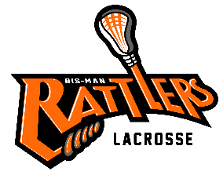
Bismarck Mandan Lacrosse Association
Board Meeting –May 25th 6pm
- Call to Order –

- Changes/additions to Agenda:

- Approval of Prior Minutes (from March)- post to website

- Reports:
  - Treasurer
    - Signature card for the bank and bank authorization of accounts – removal of old board member and who should have access to the account(s)
    - NPLL Fees: break down of where fees are used
    - Coach reimbursement fees
    - Preparation of next year’s budget (what needs to be included ie: Hudl, uniforms, coach payments)
    - Hudl reimbursement
    - Sponsorship reimbursement for shooter shirts

  - Coaches
    - Payment of coaches for next season –who will to be back for the 2023 season?

    - Advertise at U of Mary, USA Lacrosse and BSC now for next season to find recruit new coaches.

  - Equipment:
    - Needs?

  - Sponsorship
    - New sponsorships
    - Sponsor Recognition
    - Concrete wall for wall ball (if donated where to put it)
  - Fundraising:

    - Calendar Raffle

- Old Business
  - Player Handbook & Coach Handbook (Shaun & Kurt)

  - Apparel store:

- New Business

  - Refunds given:
    - Refund policy

  - End of the year picnic: Jaycees Shelter (outdoor picnic area) Monday June 13th
BMLA to provide hotdogs: Each group responsible for
Varsity: JV: Girls: 14U: 12U/10U: Little Laxers

  - Equipment turn- in plan
  - 10U/little laxer pick-up games next year
  - End of year member survey (feedback & plans for returning)
  - Artik Lacrosse camp for the boys

Comments & Announcements: Next meeting

Adjournment – Meeting Adjourned at

