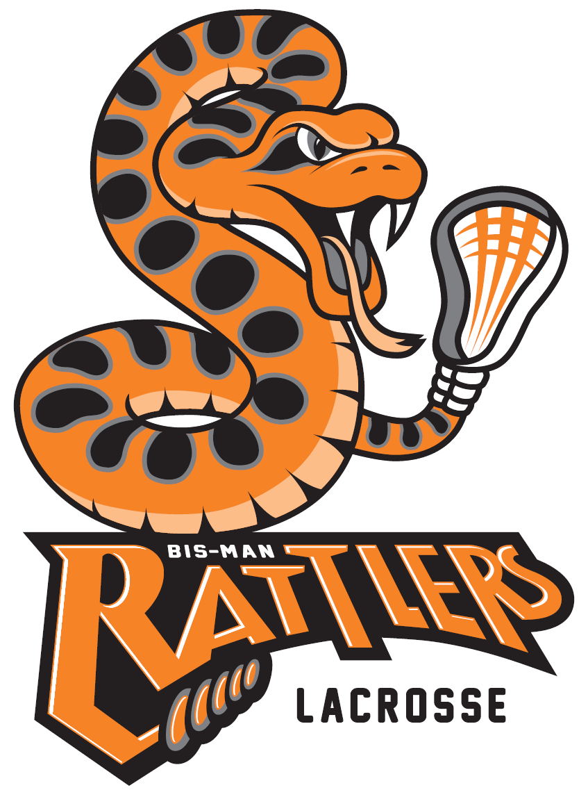
Bismarck Mandan Lacrosse Association Sponsorship
www.bismanlacrosse.org

Dear Prospective Bismarck Mandan Lacrosse Sponsor:
As we look forward to the 2022 and 2023 lacrosse seasons in the Bismarck-Mandan area, we wish to form a partnership with you, the community sponsors.
The Bismarck Mandan Lacrosse Association (BMLA) is a non-profit organization promoting the sport of lacrosse to the youth in the Bismarck‐Mandan area. The mission of BMLA is to foster a life‐long enjoyment for the game of lacrosse, through the developmental programs for youth boys and girls, ages 6 through high school. Programs include teaching individual skills, the essentials of team play, proper physical conditioning, and most importantly, good sportsmanship. BMLA encourages players to develop a positive attitude, self‐discipline, respect for others, and commitment to the success of their team and organization.

Part of our goal in raising funds for the lacrosse program is to make participation in the sport of lacrosse affordable. We feel that encouraging local business support of education and athletics through advertisement or donations will help foster a sense of community pride and ownership. Through this sponsorship, you will be benefiting the lacrosse program and all the youth athletes in our community.

The attached sponsorship order form will give you information on the costs of participating in our sponsorship program and becoming a part of the fastest growing sport on two feet.
We ask for you to consider a sponsorship, and depending on your level of commitment, would include listing your business/logo on our lacrosse website and host weekend banner recognition. With your support, we will strive to reach our goal of establishing a program based upon academic excellence, sportsmanship, and dedication.
We truly appreciate your time and thank you in advance for supporting the Bismarck Mandan Lacrosse Association Program. If you have any questions, you may email me at bismanlax@gmail.com or call me at 701-527-0845.
Warmest Regards,
Sheldon Sivak
Sheldon Sivak, Vice President
Bismarck Mandan Lacrosse Association
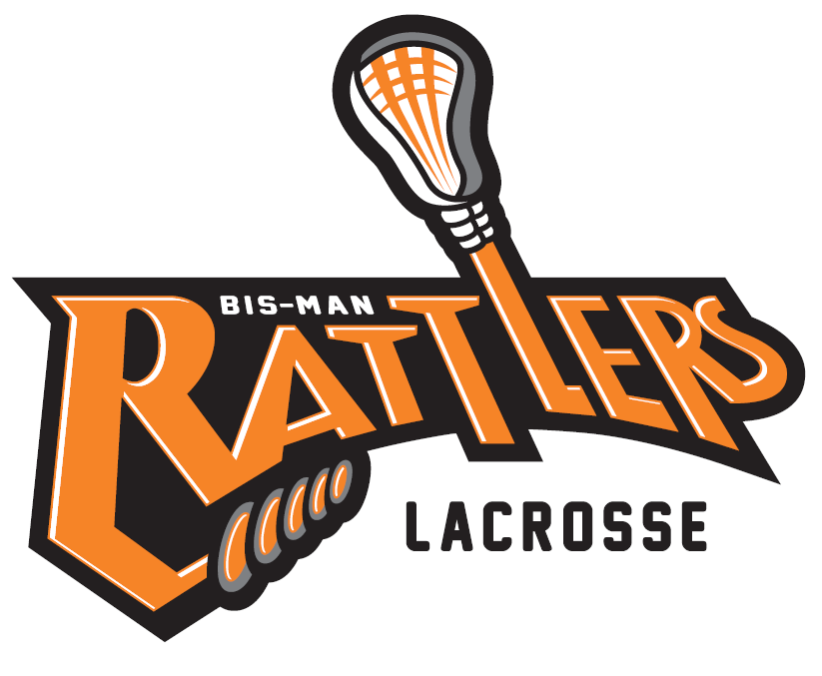
Bismarck Mandan Lacrosse Association Sponsorship Order Form

Don’t wait! Support the Rattlers and provide a sponsorship now! Complete this order form. Full payment must be received to allow the order to be processed!

Company Name:_______________________________________________________________

Address:_____________________________________________________________________

City / State / Zip:_______________________________________________________________

Contact Name:____________________________________Phone:_______________________________

Email address: _____________________________Web Site: __________________________

Point of Contact for Logo needs:__________________________________________________

Levels of Sponsorship:
$ 100 – Line-item sponsorship on our website and on host weekend banner.
$ 200 – Signage for field sponsor at host weekend, line-item sponsorship on our website and
host weekend banner.
$ 500 – Customized pop-up canopy with sponsor’s name and logo, line-item sponsorship on
our website and host weekend banner.
$ 500 – Shirts for recreation play participants including sponsor’s name and logo, line-item
sponsorship on our website and host weekend banner. (Provides roughly 30 shirts)
$2,000 – Jersey sponsorship with sponsor’s name, line-item sponsorship on our website and
host weekend banner. (Provides for 20 jerseys for the 2023 lacrosse season)
Please make checks payable to: Bismarck Mandan Lacrosse Association
PO Box 193
Bismarck, ND 58502-0193

