Agenda
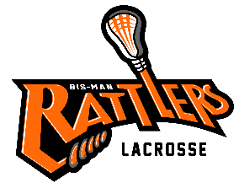
Bismarck Mandan Lacrosse Association
Board Meeting –March 3rd, 2022
- Call to Order –

- Changes/additions to Agenda:

- Approval of Prior Minutes- post to website

- Reports:
  - Treasurer

  - Coaches

  - Equipment:
- Need Rage Cage flex links

- 50/50 Parks & Rec Grant status:

- Gear wish lists for next season include:
Uniforms : too late for upcoming season?
Uniforms Vendor Quotes:
UA Men: $70 Women $52
Logo Magic $90 Women $75
Northern Trophy -
BSN-

Canopies: would like 4-sponsor item

Mesh bags color coded for size of grant gear. Vendor found

Goalie sticks Need to be restrung potential young player to do

- Grant Gear handout/

  - Sponsorship/Fundraising
    - Sponsorship request form:
- Tier sponsorships:

- Scheels sponsorship request form for sticks

- Jersey sponsorship request to Dakota Community Bank

    - Fundraising:
- Fundraising U:
- Calendar Raffle

  - Old Business
    - Holly Hendrickson – jersey sponsorship – Michael will continue to pursue sponsorship funds.

    - Player Handbook & Coach Handbook: Sent to Shaun & Kurt

    - YMCA Itty Bitty Lacrosse

    - AED training for coaches- Tara Vander Laan to offer DVD

  - New Business

    - Try Lacrosse this Saturday 2-6pm: setup needs/plan

    - Practice times cold weather/wet field options

    - Jerseys

    - Travel Schedule

    - Host weekend dates

    - Registration: Early bird ends 3/10

    - End of the year party

Comments & Announcements: Next meeting

Adjournment – Meeting Adjourned at

