Agenda
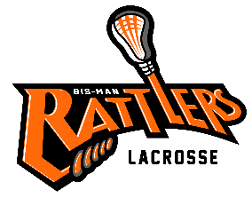
Bismarck Mandan Lacrosse Association
Board Meeting – January 13th 6pm
- Call to Order –
- Changes to Agenda:
  - Approval of Prior Minutes- post to website –http://www.bismanlacrosse.org/pages/boardofdirectors

- Reports:
  - Treasurer

  - Coach

  - Equipment:
- Need Rage Cage flex links

- All gear must be non-NOCSAE certified equipment will be donated to “It Takes a Village: Lacrosse” split shipping cost w/ Coach Kurt

- Need to do 50/50 Grant Due 2/1 equipment will include upgrading goalie gear, neck protectors, shin guards & girls' helmet

- Gear wish lists for next season include:

  - Uniforms Vendor Quotes:

  - Canopies (4) Would like to ask for sponsors to purchase canopies-Easy Ups seem to be the most affordable. W/ sponsor logo & Rattlers Logo cost is around $300 Canopy sizes 10X10

  - Mesh bags color coded for size of grant gear. Vendor found

  - 1st aid bags for coaches (5-7 bags)

  - Goalie sticks Need to be restrung potential young player to do

  - Sponsorship/Fundraising
    - Sponsorship request form
    - Jersey sponsorship

- Old Business
  - Holly Hendrickson – jersey sponsorship – Michael will continue to pursue sponsorship funds.

  - Player Handbook & Coach Handbook

  - Website update:

  - YMCA Itty Bitty Lacrosse

  - AED Training for Coaches

- New Business:

  - Board Vacancy

  - Try Lacrosse event 2/13 3:30 pm to 7:30 pm @ Dome

Comments & Announcements: Next meeting

Adjournment – Meeting Adjourned at

