Agenda
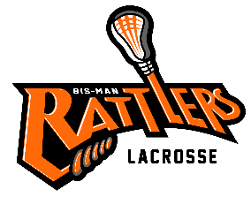
Bismarck Mandan Lacrosse Association
Board Meeting – December 7th 2021
- Call to Order –
- Changes to Agenda:
  - Approval of Prior Minutes- post to website –http://www.bismanlacrosse.org/pages/boardofdirectors

- Reports:
  - Treasurer

  - Coach

  - Equipment:
- Need Rage Cage flex links

- All gear must be non-NOCSAE certified equipment will be donated to “It Takes a Village: Lacrosse” split shipping cost w/ Coach Kurt

- Need to do 50/50 Grant Due 2/1 equipment will include upgrading goalie gear, neck protectors, shin guards & girls' helmet

- Gear wish lists for next season include:
Uniforms (Varsity/ JV for 2022 season)
Potential sponsor for new uniforms
1 vendor quote from Logo Magic: 12-15K. Look for sponsors

Canopies (4) Would like to ask for sponsors to purchase canopies-Easy Ups seem to be the most affordable. W/ sponsor logo & Rattlers Logo cost is around $300 Canopy sizes 10X10

Mesh bags color coded for size of grant gear. Vendor found

1st aid bags for coaches (5-7 bags)

Goalie sticks Need to be restrung potential young player to do

  - Sponsorship/Fundraising
    - Sponsorship request form
    - Jersey sponsorship

  - Old Business
    - Holly Hendrickson – jersey sponsorship – Michael will continue to pursue sponsorship funds.

    - Player Handbook & Coach Handbook

    - Website update:

    - YMCA Itty Bitty Lacrosse

  - New Business
- Try Lacrosse 12/12 Plans set up

ii. AED Training for Coaches

iii. Board Vacancy

Comments & Announcements: Next meeting

Adjournment – Meeting Adjourned at

