Agenda
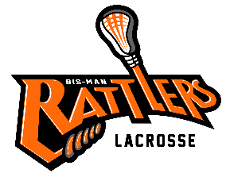
Bismarck Mandan Lacrosse Association
Board Meeting – November 16th 2021
- Call to Order –
- Changes to Agenda:
  - Approval of Prior Minutes- post to website –http://www.bismanlacrosse.org/pages/boardofdirectors

- Reports:
  - Treasurer:

  - Coach

  - Equipment:
    - Inventory:
    - BPR 50/50 Grant
    - Gear wish lists for next season include:
              - Uniforms (Varsity/ JV for 2022 season)
              - Canopies (4)
              - Mesh bags color coded for size of grant gear.
              - 1st aide bags for coaches (5-7 bags)
              - Tool box
              - Shin guards for goalies
              - Protective pants for girl goalies
              - Goalie Sticks

  - Sponsorship/Fundraising
    - Calendar Raffle
    - Jersey sponsorship (MDU)

- Old Business
  - Holly Hendrickson – jersey sponsorship – Michael will continue to pursue sponsorship funds.

  - Player Handbook & Coach Handbook

  - Website update:

  - Try Lacrosse dates/planning
  - YMCA Itty Bitty Lacrosse
  - Box Lacrosse

- New Business
  - Community exposure: Hockey tournaments

- Comments & Announcements: Next meeting

- Adjournment – Meeting Adjourned at

